

**School of Information Technology and Engineering   
  
Winter Semester 2021-22   
  
B.Tech (Information Technology)   
  
CSE1007 Java Programming**

**Slot: L27 + L28**

**Name: Anubhav Chachra**

**Reg No: 20BIT0104**

**SOURCE CODE**

*// Anubhav Chachra*

*// 20BIT0104*

package DA1.src.com.anubhav_chachra;

import java.util.Arrays;

import java.util.Random;

public class Da1 {

*// Constants*

    final static int minCredit = 12;

    final static int maxCredit = 24;

*// Declaring Student class*

    static class Student {

        private String regNo;

        private String name;

        private String dob;

        private String address;

        private String mobileNo;

        private Course[] allotedCourses; *// an array of type "Course".*

        private int totalCredits; *// total credits of all the courses.*

        private int[] marks; *// int array to store marks.*

        private char[] grades; *// char array to store grades.*

*// Constructor for Student*

        public Student(String regNo, String name, String dob, String address, String mobileNo)

                throws InstantiationException { *// I have declared this exception to throw it in case of invalid input.*

*this*.regNo = regNo;

*this*.name = name;

*this*.dob = dob;

*this*.address = address;

*this*.mobileNo = mobileNo;

        }

*// Mutator methods*

        public void setRegNo(String regNo) {

*this*.regNo = regNo;

        }

        public void setAddress(String address) {

*this*.address = address;

        }

        public void setName(String name) {

*this*.name = name;

        }

        public void setDob(String dob) {

*this*.dob = dob;

        }

        public void setMobileNo(String mobileNo) {

*this*.mobileNo = mobileNo;

        }

*// this method will set the courses for the respective student and also check if*

*// total no of credits are invalid or not.*

        public void setCourses(Course[] allotedCourses) throws InstantiationException {

*this*.allotedCourses = allotedCourses;

            for (Course c : allotedCourses) {

*this*.totalCredits += c.getCredits();

            }

*// if someone doesnt have 12 to 24 credits, then throw an exception.*

            if (totalCredits < minCredit || totalCredits > maxCredit) {

                throw new InstantiationException(

*this*.name + " does not have valid number of credits! \nMinimum credits required: "

                                + minCredit + "\nMaximum credits required: " + maxCredit);

            }

        }

*// Method to populate the marks array with random values between 0 and 100.*

        public void setMarks() {

            Random rand = new Random();

            marks = new int[allotedCourses.length];

            for (int i = 0; i < marks.length; i++) {

*this*.marks[i] = rand.nextInt(100);

            }

        }

        public void setGrades() {

*this*.grades = new char[marks.length];

            for (int i = 0; i < marks.length; i++) {

                if (marks[i] >= 90) {

                    grades[i] = 'S';

                } else if (marks[i] >= 80) {

                    grades[i] = 'A';

                } else if (marks[i] >= 70) {

                    grades[i] = 'B';

                } else if (marks[i] >= 60) {

                    grades[i] = 'C';

                } else {

                    grades[i] = 'D';

                }

            }

        }

*// Accessor methods*

        public String getRegNo() {

            return regNo;

        }

        public String getAddress() {

            return address;

        }

        public String getName() {

            return name;

        }

        public String getDob() {

            return dob;

        }

        public String getMobileNo() {

            return mobileNo;

        }

        public Course[] getAllotedCourses() {

            return allotedCourses;

        }

        public String getAllotedCoursesString() {

            Course[] courses = getAllotedCourses();

            StringBuilder sb = new StringBuilder();

            for (Course c : courses) {

                sb.append(c.courseName + ",");

            }

            return sb.toString();

        }

        public int[] getMarks() {

            return marks;

        }

        public char[] getGrades() {

            return grades;

        }

        public int getTotalCredits() {

            return totalCredits;

        }

*// Method to calculate GPA.*

        public String getGPA() {

            float gpa, sum = 0;

            for (int i = 0; i < *this*.getGrades().length; i++) {

                if (*this*.getGrades()[i] == 'S') {

                    sum += 10 * *this*.getAllotedCourses()[i].getCredits();

                } else if (*this*.getGrades()[i] == 'A') {

                    sum += 9 * *this*.getAllotedCourses()[i].getCredits();

                } else if (*this*.getGrades()[i] == 'B') {

                    sum += 8 * *this*.getAllotedCourses()[i].getCredits();

                } else if (*this*.getGrades()[i] == 'C') {

                    sum += 7 * *this*.getAllotedCourses()[i].getCredits();

                } else {

                    sum += 6 * *this*.getAllotedCourses()[i].getCredits();

                }

            }

            gpa = sum / *this*.totalCredits;

            String GPA = String.format("%.2f", gpa);

            return GPA;

        }

*// Overriden toString method to display Student details.*

        @Override

        public String toString() {

            String courses = " ";

            for (Course c : allotedCourses) {

                courses += "Course Code:" + c.getCourseCode() + " , Course Name:" + c.getCourseName() + " , Credits:"

                        + c.getCredits() + "\n\t\t  ";

            }

            return "Student Detail \n-------------------------------------\n" + "Name = " + name + "\n\nRegister No = "

                    + regNo

                    + "\n\nAlloted Courses ="

                    + courses + "\n-------------------------------------";

        }

    }

*// Declaring Course class*

    static class Course {

        private String courseCode;

        private String courseName;

        private int credits;

*// Constructor for Course class.*

        public Course(String courseCode, String courseName, int credits) {

*this*.courseCode = courseCode;

*this*.courseName = courseName;

*this*.credits = credits;

        }

*// Mutator methods*

        public void setCourseCode(String courseCode) {

*this*.courseCode = courseCode;

        }

        public void setCourseName(String courseName) {

*this*.courseName = courseName;

        }

        public void setCredits(int credits) {

*this*.credits = credits;

        }

*// Accessor Methods*

        public String getCourseCode() {

            return courseCode;

        }

        public String getCourseName() {

            return courseName;

        }

        public int getCredits() {

            return credits;

        }

*// Overriden toString() method to display Course details.*

        @Override

        public String toString() {

            return "Course Name = " + courseName + ", Course Code = " + courseCode + ", Credits = " + credits;

        }

    }

    public static void main(String[] args) throws InstantiationException {

*// Declaring students and courses arrayss.*

        Student[] students = new Student[10];

        Course[] courses = new Course[10];

*// Populating students array with student objects.*

        students[0] = new Student("001", "Anubhav", "08/11/2001", "Faridabad", "7217818288");

        students[1] = new Student("002", "Bhavik", "2/2/2001", "Gujarat", "9876543210");

        students[2] = new Student("003", "Chetan", "3/3/2002", "Mumbai", "9451562948");

        students[3] = new Student("004", "Dheeraj", "4/4/2001", "Chennai", "7811556181");

        students[4] = new Student("005", "Eshan", "5/5/2002", "Delhi", "9894533210");

        students[5] = new Student("006", "Farhan", "6/6/2001", "Lucknow", "7893254160");

        students[6] = new Student("007", "Gauri", "7/7/2002", "Punjab", "9899955210");

        students[7] = new Student("008", "Harsh", "8/8/2001", "Kerela", "9786453021");

        students[8] = new Student("009", "Ishank", "9/9/2002", "Tamil Nadu", "8523697410");

        students[9] = new Student("010", "Jasmine", "10/10/2001", "West Bengal", "7987654321");

*// Populating courses array with course objects.*

        courses[0] = new Course("CSE1002", "OOPS", 3);

        courses[1] = new Course("ITE1015", "SwE", 3);

        courses[2] = new Course("MAT2001", "Calc", 4);

        courses[3] = new Course("MAT3004", "Ala", 4);

        courses[4] = new Course("CSE1007", "Java", 3);

        courses[5] = new Course("ITE1004", "DSA", 3);

        courses[6] = new Course("ITE2002", "OS", 4);

        courses[7] = new Course("ITE3001", "DCCN", 4);

        courses[8] = new Course("ITE1003", "DLM", 4);

        courses[9] = new Course("ITE3002", "CAO", 3);

*// Allocating courses to students.*

        students[0].setCourses(new Course[] { courses[0], courses[1], courses[2], courses[4] });

        students[1].setCourses(new Course[] { courses[3], courses[4], courses[5], courses[6] });

        students[2].setCourses(new Course[] { courses[7], courses[8], courses[9], courses[0] });

        students[3].setCourses(new Course[] { courses[1], courses[2], courses[3], courses[4] });

        students[4].setCourses(new Course[] { courses[5], courses[6], courses[7], courses[8] });

        students[5].setCourses(new Course[] { courses[9], courses[0], courses[1], courses[2] });

        students[6].setCourses(new Course[] { courses[3], courses[4], courses[5], courses[6] });

        students[7].setCourses(new Course[] { courses[7], courses[8], courses[9], courses[0] });

        students[8].setCourses(new Course[] { courses[1], courses[2], courses[3], courses[4] });

        students[9].setCourses(new Course[] { courses[5], courses[6], courses[7], courses[8] });

*// Displaying students details.*

        printStudentDetails(students);

*// Students who have registered for the same courses.*

        studentsWithSameCourse(students);

*// Results of students*

        studentResult(students);

*// End of main method.*

    }

*// Below are ALL the display methods compiled at one place.*

*/\**

*\* This is the method to display the name of every student along with their*

*\* registration number and*

*\* the list of courses allocated*

*\* to every student.*

*\*/*

    static void printStudentDetails(Student[] students) {

        for (Student s : students) {

            System.out.println(s.toString());

        }

    }

*/\**

*\* Display the name and registration number of the students who registered for*

*\* the same list of courses.*

*\*/*

    static void studentsWithSameCourse(Student[] students) {

        int flag = 0;

        for (int i = 0; i < students.length; i++) {

            for (int j = i + 1; j < students.length; j++) {

                if (Arrays.equals(students[i].getAllotedCourses(), students[j].getAllotedCourses())) {

                    flag = 1;

                    System.out.println("-----------------------------------------------------------------");

                    System.out.println("For these courses: " + (students[i].getAllotedCoursesString()) + "\n");

                    System.out.println("These students have registered : \n");

                    System.out.println("Name :" + students[i].getName() + ", Register No. :" + students[i].getRegNo());

                    System.out.println("Name :" + students[j].getName() + ", Register No. :" + students[j].getRegNo());

                    System.out.println("-----------------------------------------------------------------");

                }

            }

        }

*// in case no students have common courses.*

        if (flag == 0) {

            System.out.println("No students are having the same courses");

        }

    }

*/\**

*\* This is the method to display the student registration number and name (at*

*\* the top), the list of*

*\* courses along*

*\* with the grade obtained in the course (in the middle) and the GPA (at the*

*\* bottom).*

*\*/*

    static void studentResult(Student[] students) {

        for (Student s : students) {

            s.setMarks();

            s.setGrades();

            StringBuilder sb = new StringBuilder();

            for (int i = 0; i < s.getAllotedCourses().length; i++) {

                sb.append(s.getAllotedCourses()[i].getCourseName() + "\t\t\t\t  " + s.getGrades()[i] + "\n");

            }

            System.out.println("\t   Student Result\n\t   --------------\n\nRegister No: " + s.getRegNo() + "\t\t"

                    + "Name : "

                    + s.getName() + "\n" + "\nSubject\t\t\t\tGrades\n------------------------------------------\n" + sb

                    + "------------------------------------------\n\n\t\tGPA: " + s.getGPA() + "\n\n"

                    + "------------------------------------------");

        }

    }

}

**OUTPUT SCREENSHOTS**

**Printing student details**

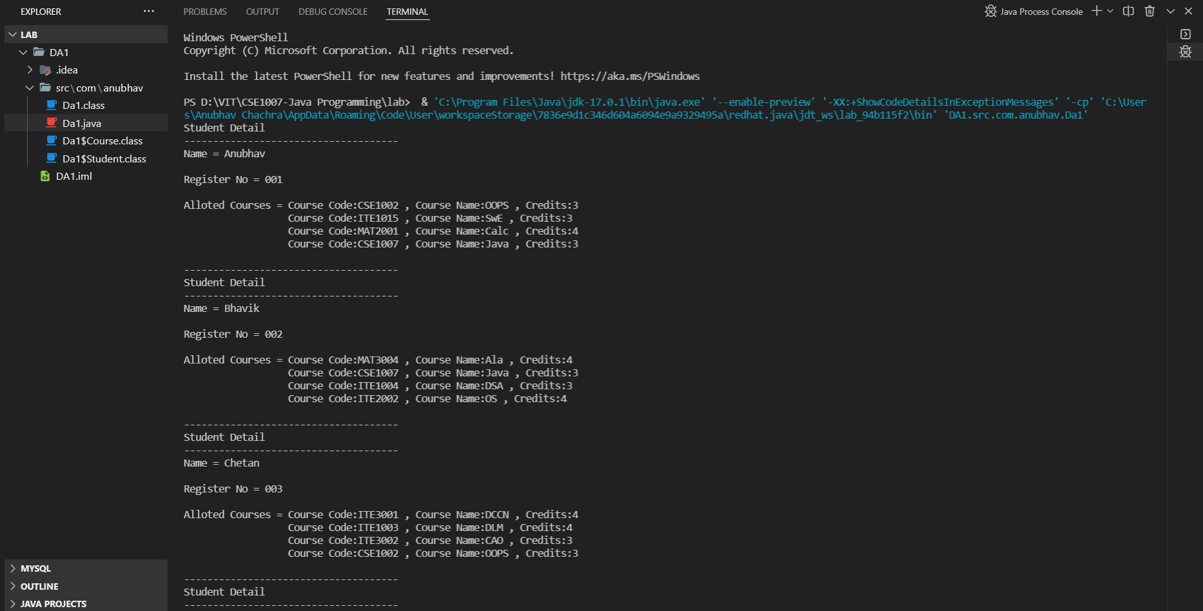

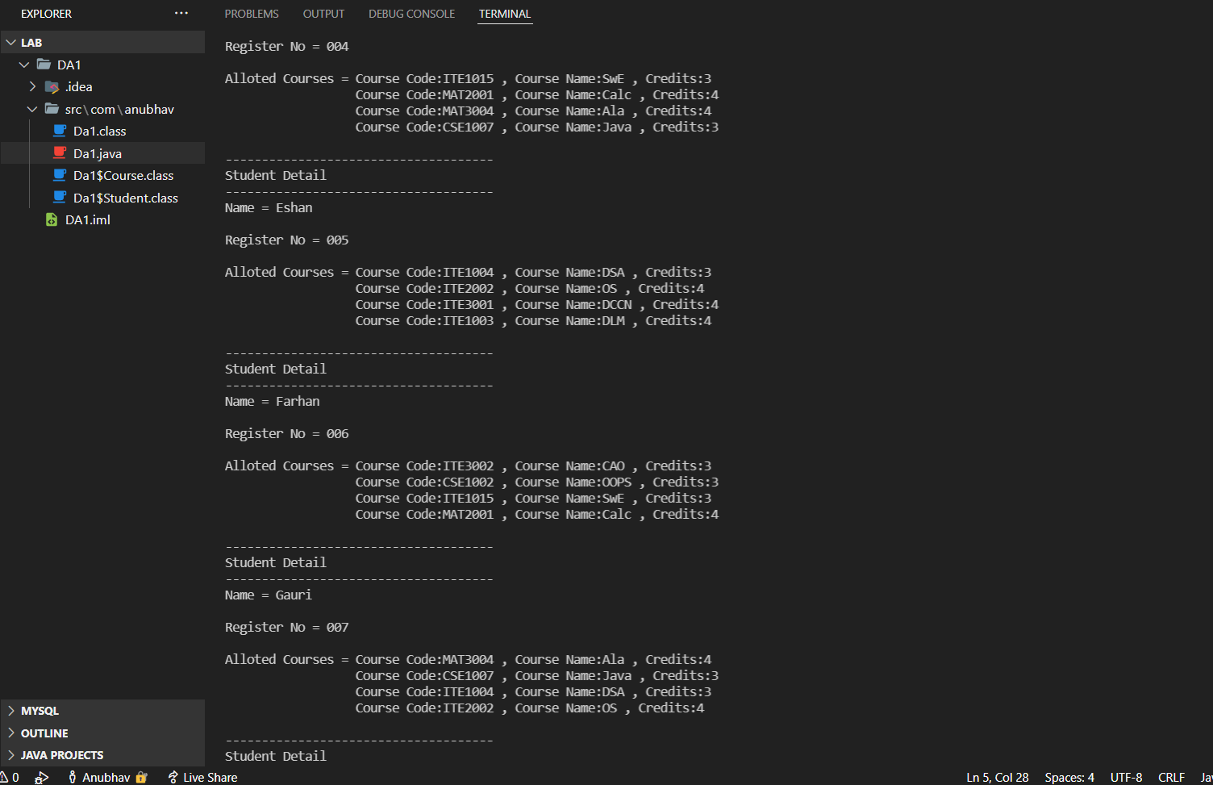

**Students who have the same courses**

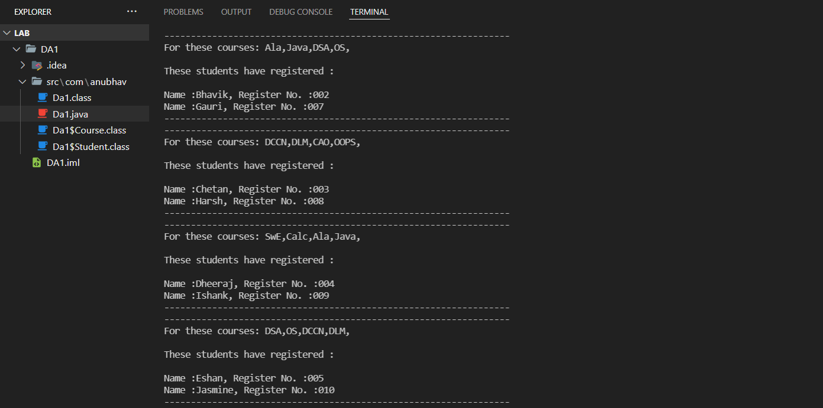

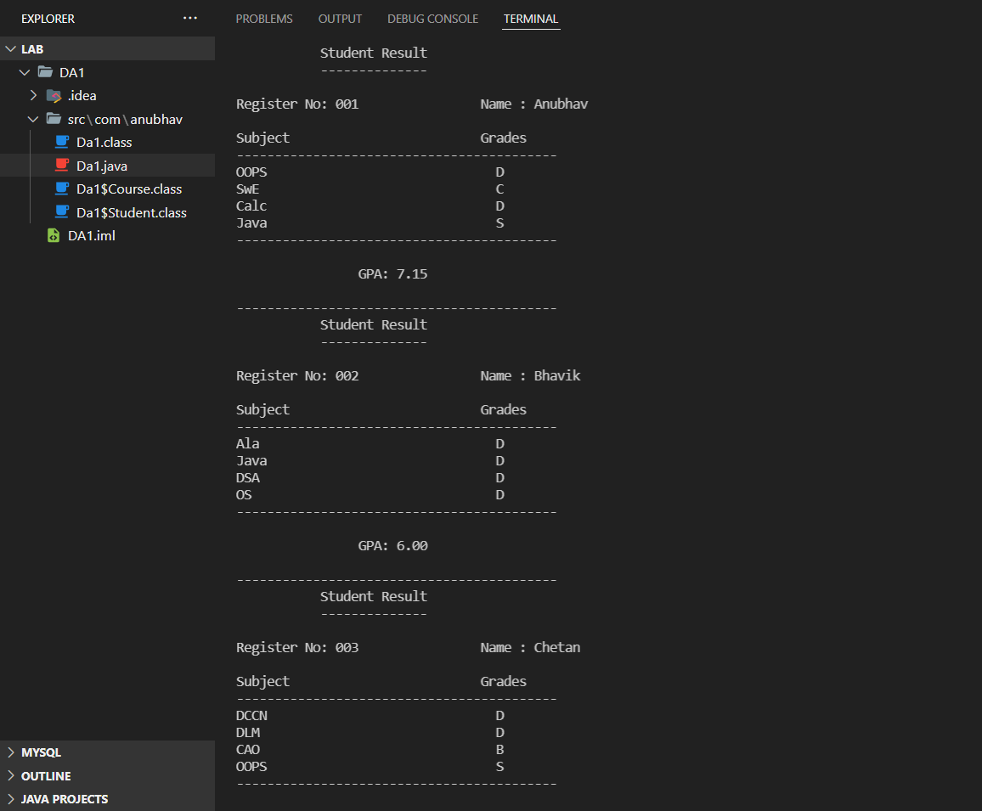**Student Result with grades and GPA**

